|  |  |  |  |  |  |
| --- | --- | --- | --- | --- | --- |
| Date | 2-Dec-22 | | | Tester Name | Jessie Liu |
| Environment | Select Environment | | | Login used |  |
| Operating System | Select OS | Version: | Update: | | |
| Software Used | Select Software | Version: | Update: | | |
| Select Software | Version: | Update: | | |
| Release version |  | | | | |
| Title | Enrolment | | | | |
| Test Type | Regression | | | | |
| Test Scenario | Re-enrolment via SIN - Same employer deferred MEPP status | | | | |
|  |  | | | | |
| Expected Results |  | | | | |
| Pass/Fail | Pass | | | JIRA# | N/A |

Describe your steps with screenshots:

1. Find a MEPP member who has deferred status

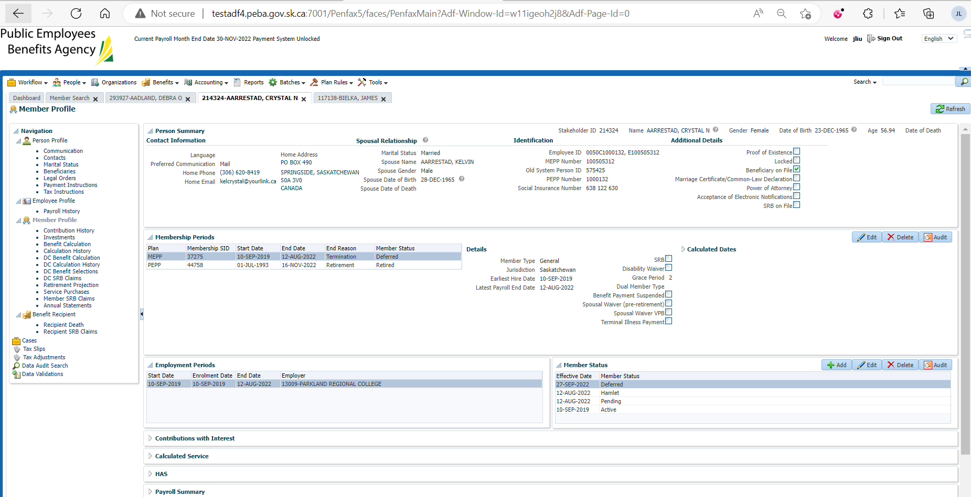

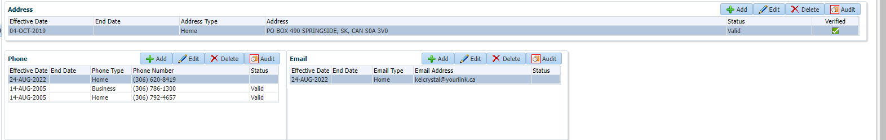

1. Log in MEPP DCT

Upload enrolment file



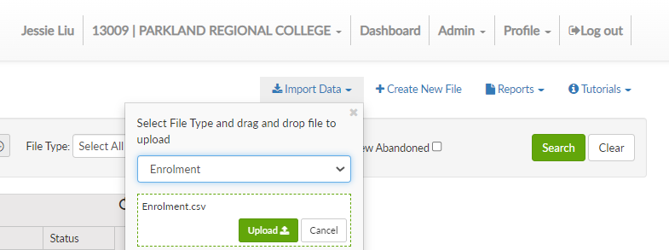

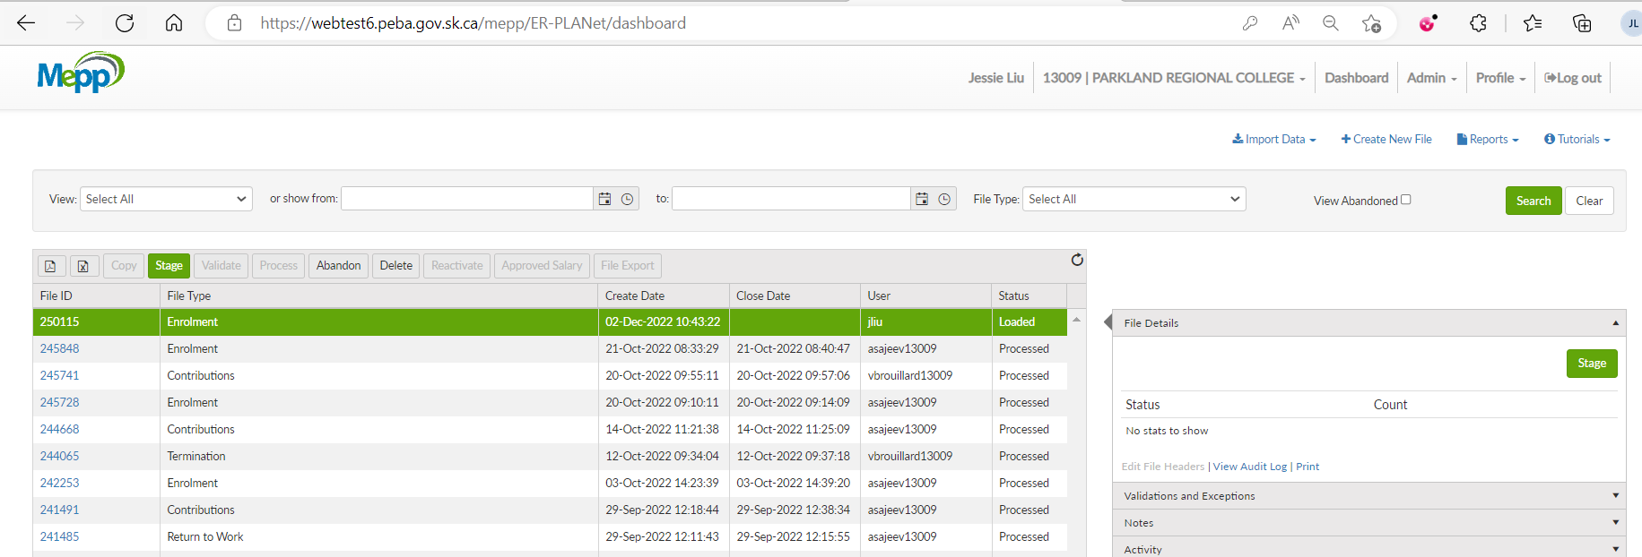

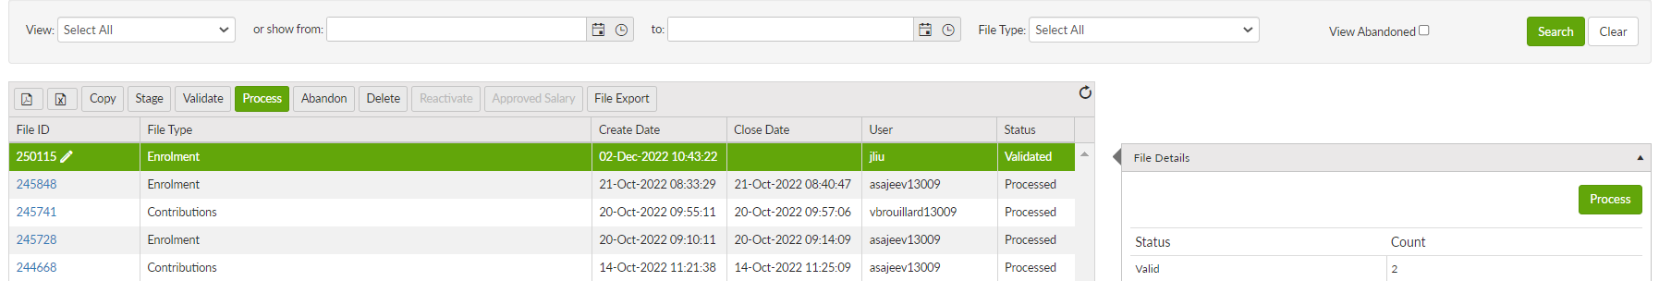

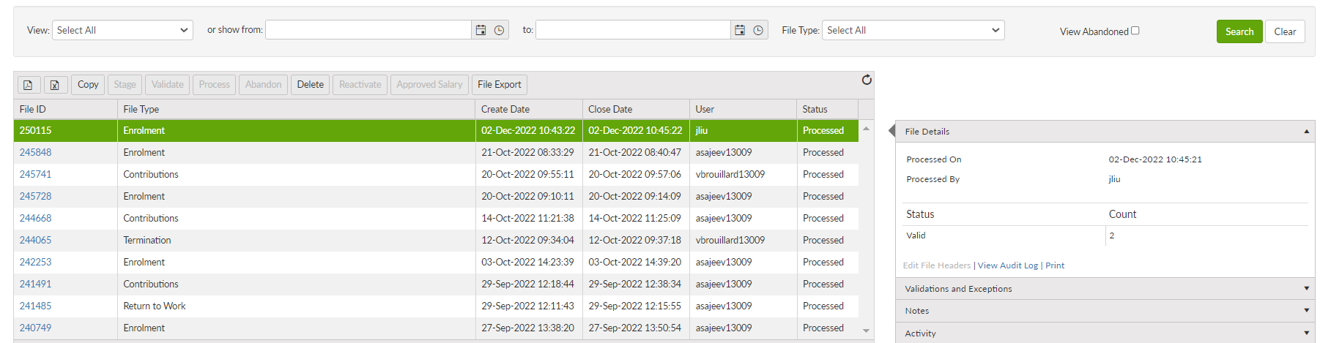

1. Data posting batch

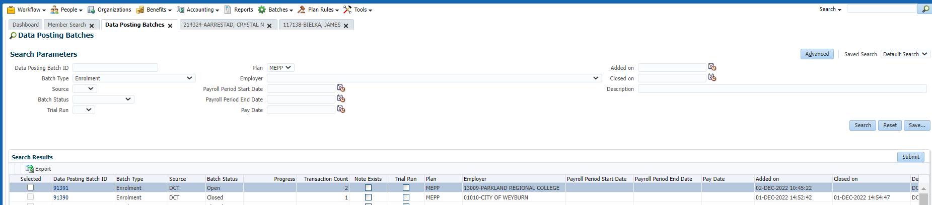

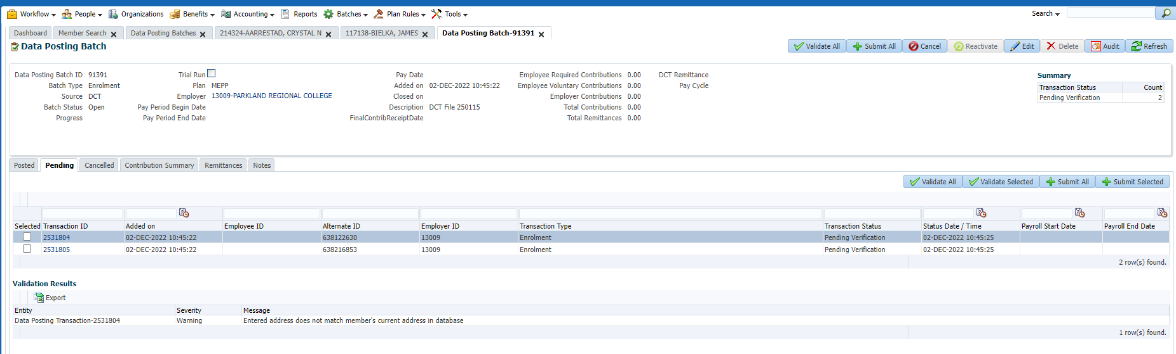

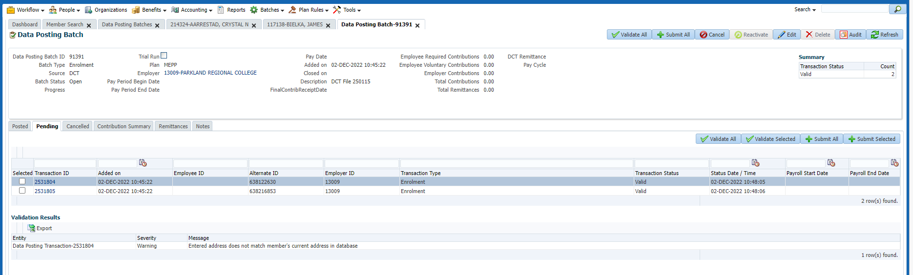

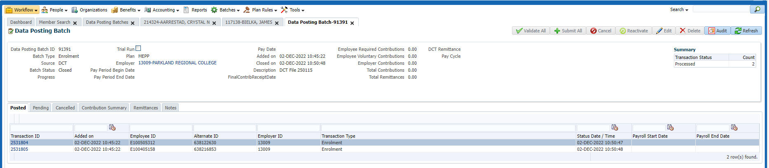

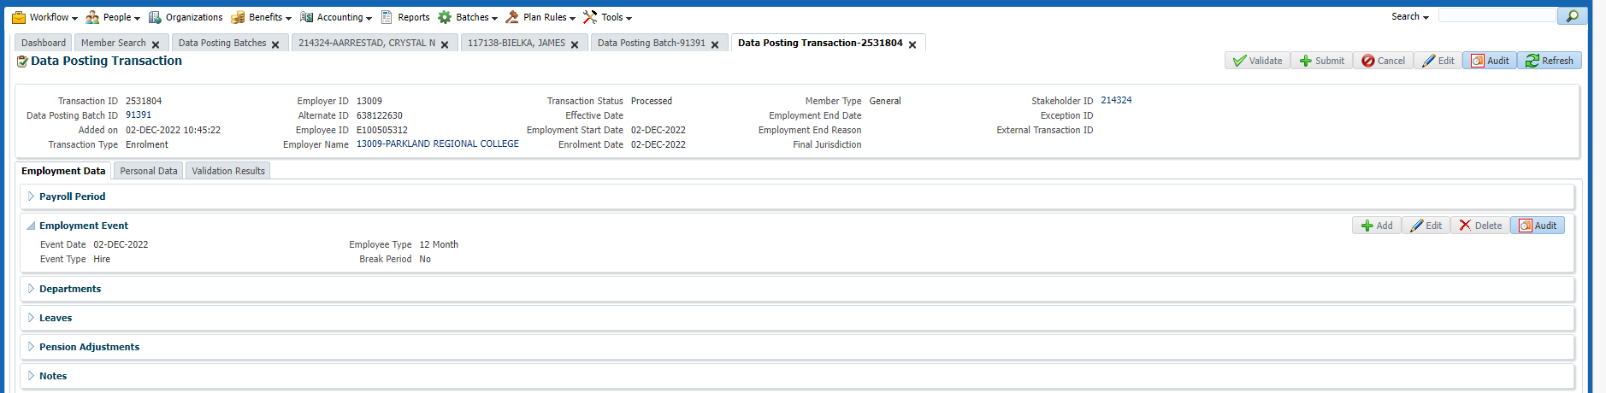

1. The member is active

